Revision Questions
Lab 21
Example Multi-Choice Questions

1. The postal delivery system is analogous with ___________________ protocols
- Virtual circuit
- Connectionless
- Connection free
- Connection oriented

2. Which is a wide area networking (WAN) protocol
- Ethernet
- Token Ring
- Apple talk
- Frame relay

3. An interconnection device at the OSI’s physical layer is a ______________________.
- Router
- Switch
- Repeater
- Bridge

4. Communication between two completely different email systems may be performed by a __________.
- Router
- Gateway
- Gatekeeper
- Bridge

5. A “Frame” is a unit of data at layer __________________ of the OSI model.
- Network
- Physical
- Datalink
- Transport

6. In protocol packets, the data portion is carried in the information or payload field, while the control portion is carried in the ___header___ field.

7. The forth layer in the OSI Refence Model is called the ___Transport____layer.

8. If you want to download a lot of information in a short time, you need a lot of ___bandwidth___.

9. The basic building blocks of a computer network include repeaters, hubs, switches and __routers__.

10. Protocols handle the “What Ifs” of network communications. True or False

11. Many protocols are modelled after either; (1) telephone calls or (2) sending a message via the __postal service___.

12. The OSI Refence model has ___7___ layers.

13. Identify the topologies of the network diagrams (a-e) below

a.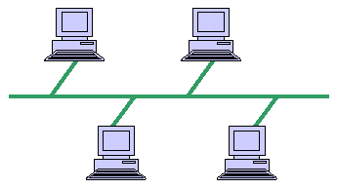Bus
b.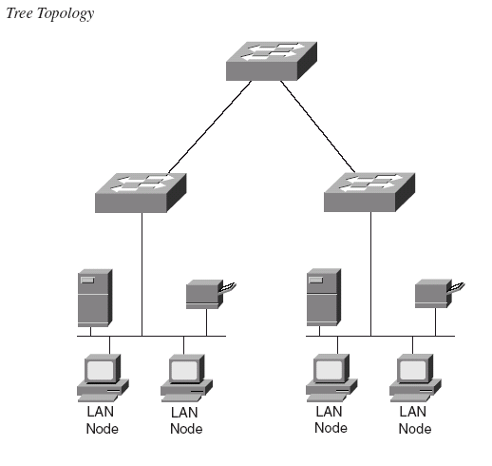Tree

c.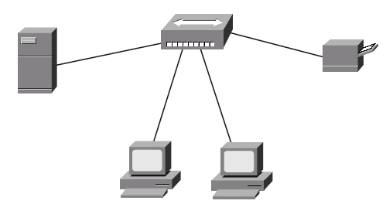 Star
d.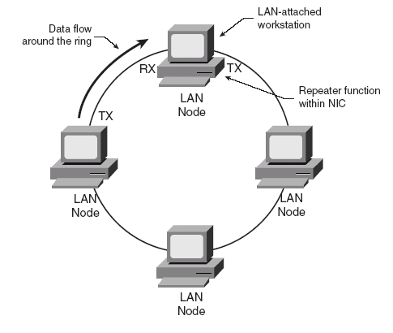 Ring
e.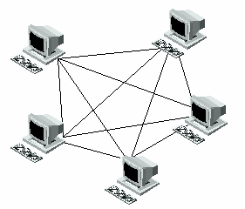Full mesh (look up differences)

14. A “protocol” is a:
- Reference Model
- Set of rules for communications
- Packet header
- Symbol that indicates the start of a packet

15. In the OSI Reference Model, layer 3 is where we find:
- Session protocols
- Applications
- Routing
- End to end integrity

16 .Standards are important because they provide
- Closed procurements
- Proprietary systems
- Virtual circuits
- Open systems

17. A packet is:
- A unit of data that is sent using given protocol
- A symbol that indicates the beginning of a submission
- A protocol header
- An 8-bit byte (octet)

18. The basic network interconnect building blocks include hubs, routers and __________.
- Terminals
- Servers
- PC client
- Switches

19. Key networking performance parameters include _____________, throughput, availability, and data integrity.
- Delay
- Payload identification
- Routing
- Repeaters

20. After the implementation IP v4, why was there a need for the development of IP v6?

We ran out of IPv4 addresses so had to move to a newer technology.

21. In IP v4 what is the default subnet mask of Class C
255.255.255.000

22. In IP v4 what is the default subnet mask of Class B
255.255.000.000

23. In IP v4 what is the default subnet mask of Class A
255.0.0.0

